Using Nero Recode and IfoEdit to Create the Mutitle DVD without Delay

In this guide, I am going to use the movie “Finding Nemo” as a sample DVD and DVD Shrink, Nero Recode, and IfoEdit as programs needed for this job

- First of all, I have to back my DVD up to the hard drive. Load my DVD and open my DVD with DVD Shrink or DVD Decrypter. For this guide, I use DVD Shrink and back up main movie only. You can’t use Nero Recode to decrypt your movie because it isn’t built for decrypting copy protected DVDs. See the screen shot:

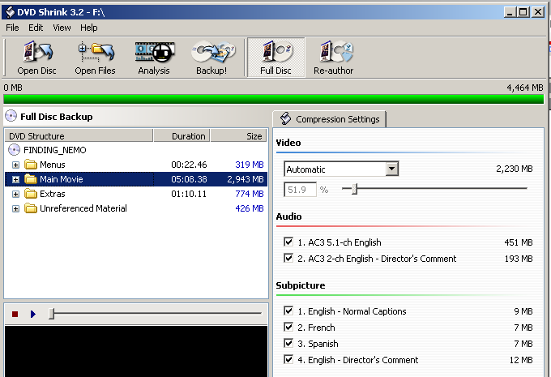

2- You can back up the full disc or the main movie only. For the purpose of this guide, I need the main movie only. Press Re-author button. In the right pane, under the Main Movie, click and drag the title I want to proceed (for example: Title 1) and drop it in the DVD Structure pane on the left side. Press Backup button and save it to my hard drive. See the screenshot:

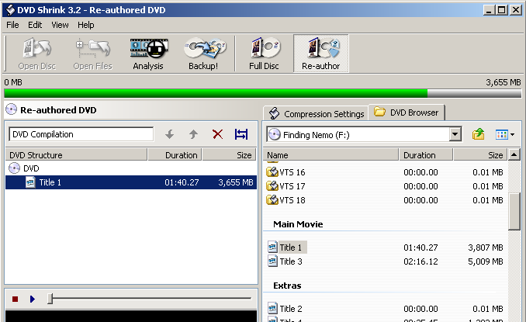

3- After saving the movie to my hard drive, start Nero Recode and select the Remake a DVD option. Press the Import Titles button. See the screenshot:

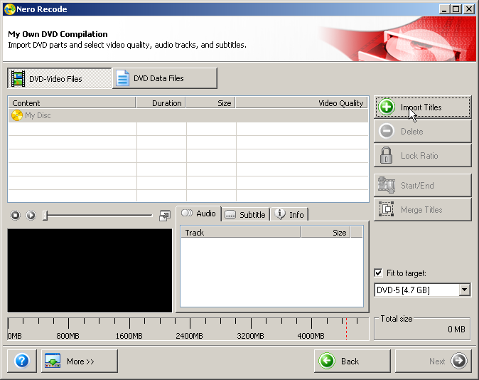

4- When I press the Import Titles button, the Import Title dialog will pop up. Browse to where I saved my movie, select the Title 1, press the Add Title button, and then click Close. See the screenshot:

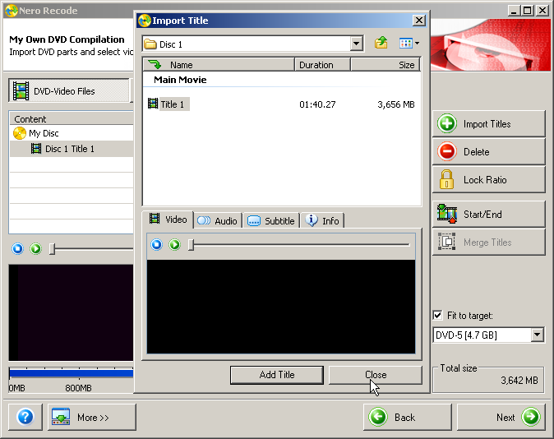

5- Click the Start/End button to open the Set Start/End Frames dialog. Select the chapter at the beginning of the movie clip on the Start frame and the end of the movie clip. In this guide, I select the chapter 6 for start frame and chapter 7 for end frame. Click OK when done. See the screenshot:

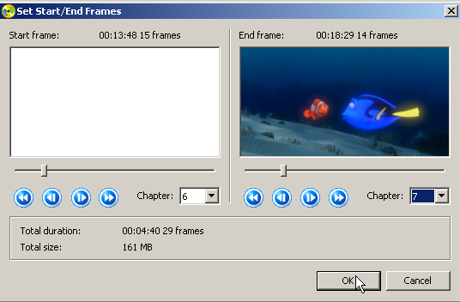

6- Now do the steps 4 and 5 to import the different backed up title. In this guide, I use only the movie Finding Nemo to demonstrate the. You can back up many more movies as you like to compile though. In this step, after importing the different title, I use the Start/End to save chapters 18 and 19. See the screenshot:

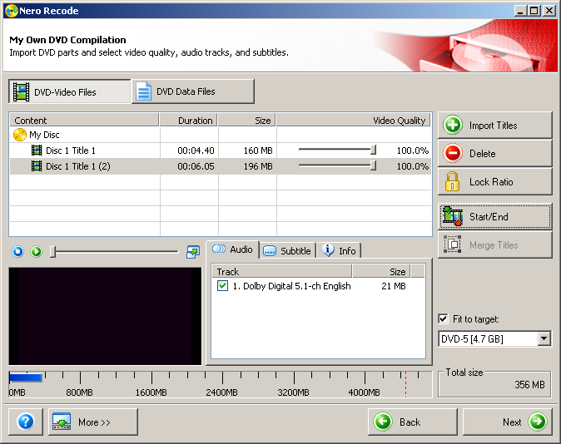

7- Next, I do the steps 4 and 5 again for different backed up title. This time, I select chapters 23 and 24. See the screenshot:

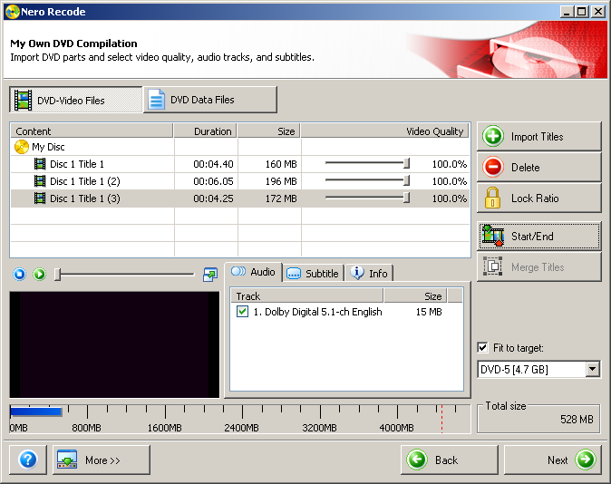

8- Now it’s time to select all the titles and merge them together. I can click and drag to select my 3 titles or press Ctrl key and click each title one-by-one. See the screenshot:

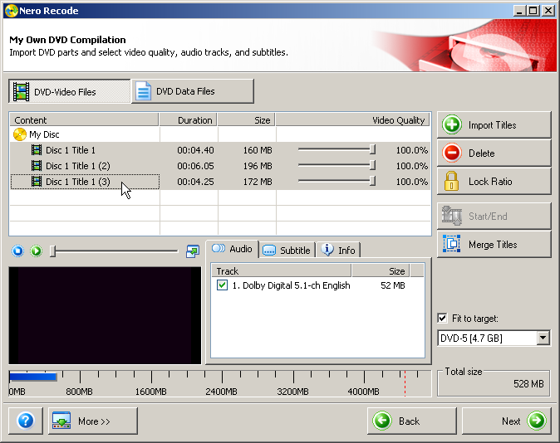

9- Click the Merge Titles button to merge all the title together. See the screenshot:

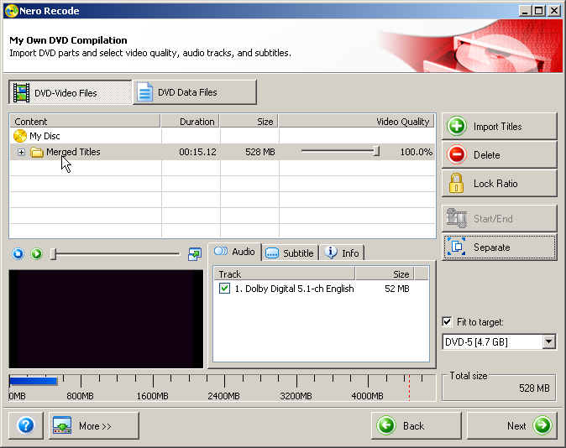

10- Click Next button. I choose Hard Disk Folder for Destination and make a new Nero Recode folder for Target folder. Click Burn and wait for Nero Recode to complete. See the screenshot:

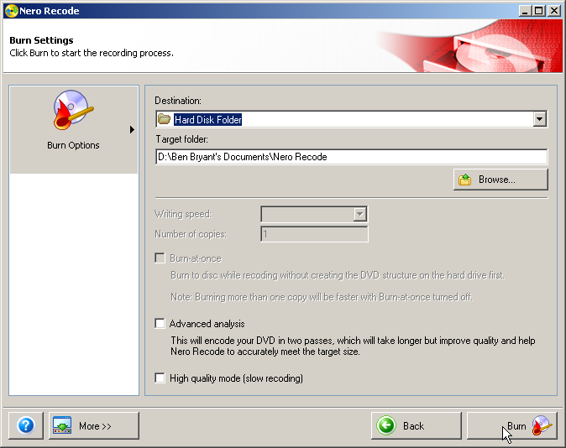

11- If I burn my backup right away, I’ll experience the problem with “time delay” when playing with DVD player. The reason is that Nero Recode only merges the titles without rebuilding a true single title only. Therefore, I need a great free tool called IfoEdit to fix this time delay problem. You can download the IfoEdit 0.971 from here:

http://www.ifoedit.com/

12- Open IfoEdit and press the Create IFOs button near the bottom. When the Create new IFO files dialog appears, on the 1st VOB of Title-Set, I press the small button and browse to the Nero Recode folder when I saved my file and select the VTS_O1_1.VOB. Click OK and wait for IfoEdit to complete. Close IfoEdit when done. See the screenshot:

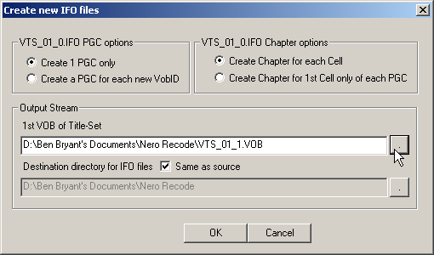

In order to be sure that my new backup in the Nero Recode folder is truly single title and DVD compliance, I open it with DVD Shrink and happy to see that: DVD Shrink can open it without any error and there is only 1 title in this movie backup. I burn my DVD with Nero and feel so good to see NO TIME DELAY. See the screenshot:

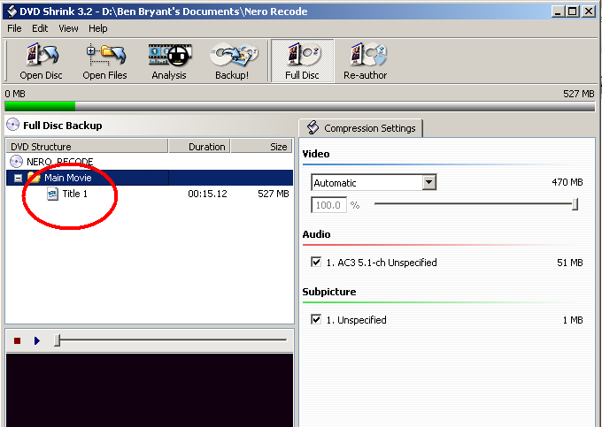

DONE

