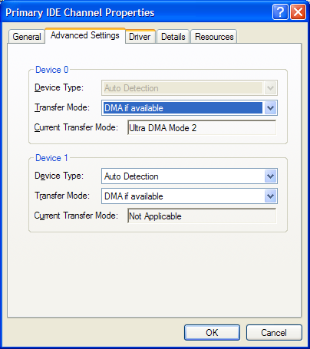

I tried burning another DVD Mission Impossible 2 using DVD43 and DVDShrink, but I get the same problem, no errors and it plays fine on the PC but when I get to chapter 8 (This sometimes changes) It starts getting jerky.

So I uninstalled all 5 entries under IDE ATA\ATAPI controllers, then rebooted, then it prompted for 2 more reboots which I did and now it looks like this:
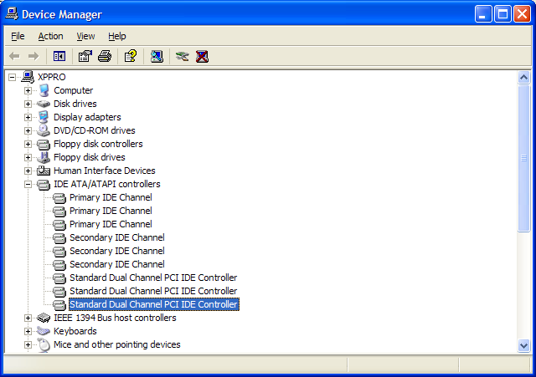

Which looks very odd to me, but in the properties of the first Primary IDE channel it does at least look like this now:
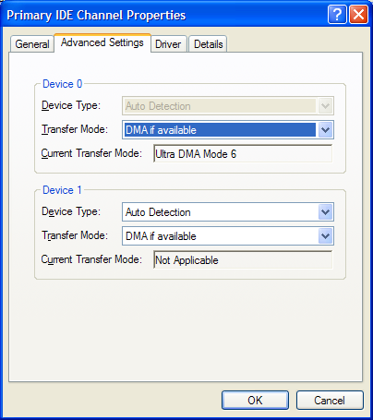
My registry also looks like this:
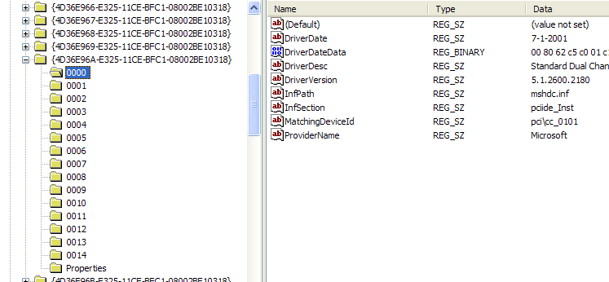
So I’m not sure which I should change according to the article.

Sorry if I have waffled just hope that his makes sense to someone.

J

